# SAVITRIBAI PHULE PUNE UNIVERSITY

**A PROJECT REPORT ON**

**“AUTOMATIC FAN CONTROL SYSTEM”**

**BACHELOR OF**

**ENGINEERING**

**IN**

**COMPUTER ENGINEERING**

**BY**

Aadarsh Jadhav

Rohit Kulkarni

# UNDER THE GUIDANCE OF

Prof.S.R. Lomate



**Department Computer Engineering**

**Keystone school of Engineering.**

# Near Handewadi Chowk, Urali Devachi, Shewalewadi, Pune –

**412308**

**(2020-2021)**



**SHALAKA FOUNDATIONS’S KEYSTONE SCHOOL OF ENGINEERING**

**CERTIFICATE**

This is to certify that Project Entitled

**“AUTOMATIC FAN CONTOL SYSTEM ”**

SUBMITTED BY

Aadarsh Jadhav Exam No: B151184201

Rohit Kulkarni Exam No: B151184236

Is a bonafide work carried out under the supervision of Prof. Somnath Lomate and it is approved as the fulfilment of the requirement of Bachelor of Engineering (Computer Engineering) project.

------------------ ------------------ --------------- ---------------

**Prof. V.G. Mankar Prof. Sarika Patil Principal External**

[Project Guide [Project Coordinator] Keystone school of HOD] Department of Engineering

Department of Computer Engineering

Computer

Engineering

# ACKNOWLEDGMENT

Every orientation work has an imprint of many people and it becomes duty of author to express deep gratitude for the same.

We would like to take this opportunity to express true sense of gratitude towards our project guide and our head of the department **Prof. Somnath Lomate** for his valuable co-operation and guidance that gave us for this project.

We would also like to express our appreciation and thanks to all those who knowingly or unknowingly have assisted us & encouraged us for our project.

**INDEX**

|  |  |  |
| --- | --- | --- |
| **Sr. No.** | **Content** | **Page No.** |
| 1 | Introduction | 5 |
| 2 | Objectives | 7 |
| 3 | Requirements | 9 |
| 4 | Working | 14 |
| 5 | Circuit Diagram | 16 |
| 6 | Flow Chart | 19 |
| 7 | Applications | 21 |
| 8 | Conclusion | 23 |
| 9 | References | 25 |

**CHAPTER NO.1**

**INTRODUCTION**

**1. Introduction**

In this project, we will learn how to make the Automatic Fan Control System using Arduino. The idea behind the project is to control the speed of the fan by difference in temperature. The Temperature variation in the fan is a different way to deal with the speed of the motor. It is a process in which the objects temperature is measured and the way of heat energy passes into or out of the object is correctly adjusted to achieve a stable temperature.

The circuit used in this project is very simple which includes Arduino, DC Motor, LCD, Temperature Sensor, Battery, Breadboard. Arduino controls the complete processes like taking the temperature of surrounding from temperature sensor in Analog form and converting it into digital, and sending output to the LCD display, speed of the fan is varied according to the room temperature using Pulse Width Modulation technique.

Electric fan is one of the most popular electrical devices due to its cost effectiveness and low power consumption advantages. It is a common circuit and widely used in many applications. This fan control system will help make surrounding more convenient and comfortable. Fans with temperature sensor control give the best of both worlds with energy savings and consistent comfort along all season.

**CHAPTER NO. 2**

**OBJECTIVES**

**2. Objectives**

The objectives of the Automatic Fan Control System are as follows:

1. The main purpose of this device is to control the speed of the fan. It can be linearly control automatically depending on the room temperature.
2. To design a controller using temperature sensor.
3. To analyses the performance of the controller.

## CHAPTER NO. 3

**REQUIREMENTS**

### 

**3. Requirements**

### 1. Arduino

Arduino UNO is a development board which contains microcontroller in the board itself. It is an open-source software. In the electronics platform, Arduinos easy to use hardware and software. The Arduino boards can read inputs so that they can understand and give as some of the outcomes like light on a sensor, a finger on a button, activating a motor, turning on an LED

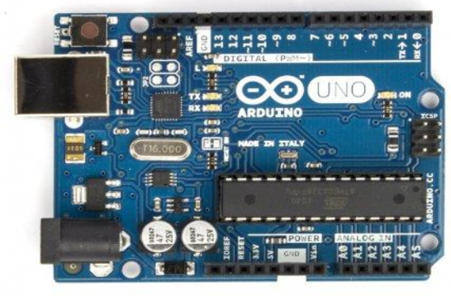

**2. 16*2 LCD display**

Liquid crystal displays (LCDs) have found enormous success in the

past couple of decades. Their function is to modify the state of light

produced by a light source in order to display images.

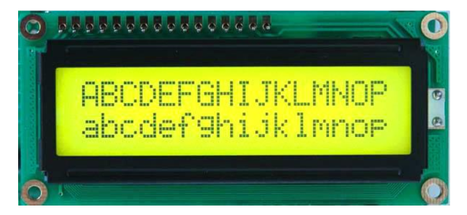

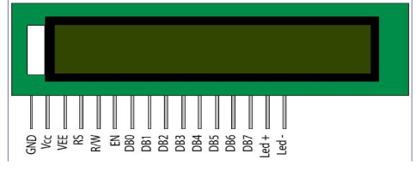

**3. Temperature sensor**

Temperature sensor senses the room temperature. This electronic device converts the data that sensed in the surrounding into the electronic data for recording purpose. There are many different types of temperature sensors. Here in this project, we are using LM 35 temperature sensor.

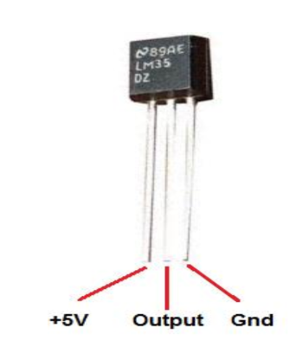

**4. DC Motor**

A DC motor is any of a class of rotary electrical motors that converts direct current electrical energy into mechanical energy. DC motors take electrical power through direct current, and convert this energy into mechanical rotation.



## CHAPTER NO. 4

**WORKING**

### 4. Working

Temperature sensor LM35 senses the temperature and converts it into an electrical (Analog) signal, which is applied to the ATmega328 microcontroller of the Arduino UNO Board. The Analog value is converted into a digital value. Thus, the sensed values of the temperature and speed of the fan are displayed on the LCD. When the temperature exceeds 20°C the fan starts rotating.

|  |  |  |  |
| --- | --- | --- | --- |
| **Sr. No** | **Temperature (in °C)** | **Duty Cycle** | **Speed** |
| 1 | 0 to 20 | 0% | Zero |
| 2 | 20 to 22 | 20% | Very Slow |
| 3 | 22 to 24 | 40% | Slow |
| 4 | 24 to 26 | 60% | Medium |
| 5 | 26 to 29 | 80% | Fast |
| 6 | 30 Above | 100% | Very Fast |

**CHAPTER NO. 5**

**CIRCUIT DIAGRAM & CONNECTIONS**

### 5. Circuit Diagram & Connections

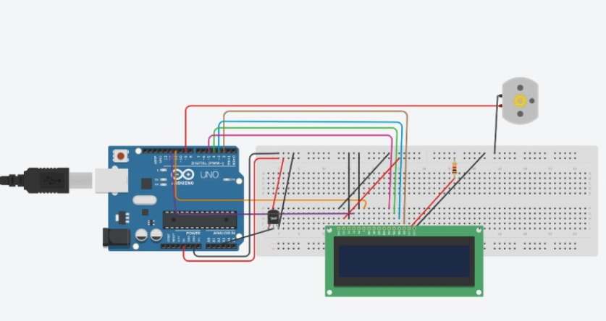

First of all, we will make a connection from Arduino to the temperature sensor. For connecting the temperature sensor, we are using digital pins 5V and GND of Arduino.

To connect the DC motor with the Arduino, use digital pin 9 of Arduino to output the PWM pin of the DC motor.

Now we will connect the Arduino to LCD 16×2.

1. Arduino pin 5v and GND connected to temperature sensor.
2. Output pin of the temperature sensor is connected to pin A1of Arduino.
3. Pin 2 of Arduino is Connected to pin DB7 of LCD.
4. Pin 3 of Arduino is Connected to pin DB6 of LCD.
5. Pin 4 of Arduino is Connected to pin DB5 of LCD.
6. Pin 5 of Arduino is Connected to pin DB4 of LCD.
7. Pin 12 of Arduino is Connected to pin RS of LCD.
8. Pin 11 of Arduino is Connected to pin E of LCD.
9. Pin VCC and GND of LCD are connected to the register.

**CHAPTER NO. 6**

#### FLOW CHART

**6. Flow Chart**

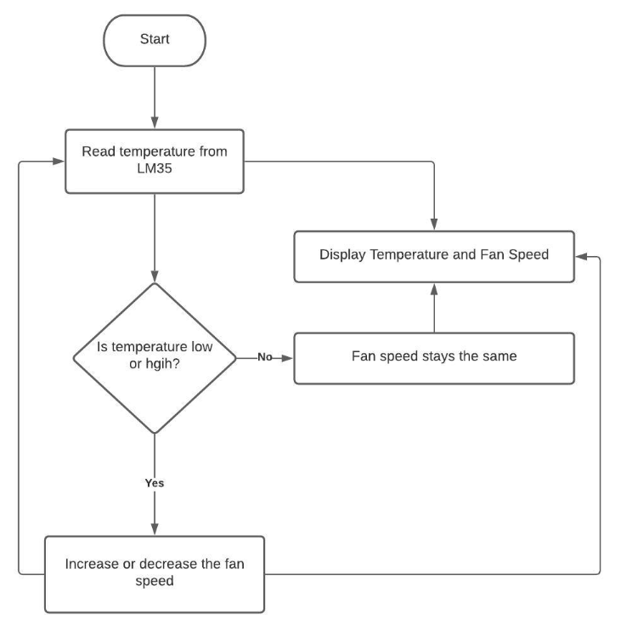

## CHAPTER NO. 7

## 

## APPLICATIONS

## 

**7. Applications**

Many researches focusing on automatic temperature control

system application in different fields will gain the benefits.

Following are some examples -

1. Temperature based fan speed controller is useful for cooling the processors in the laptops and personal computers more efficiently. Generally, fan in the laptop comes with only two or three possible speeds. So, it results in more power consumptions.
2. The fan designed in this project has different values of speeds according to temperature change. This can be also used in small scale industries for cooling the electrical/ mechanical equipment. The whole circuit except motor and fan can be manufactured on the single PCB, and it can be used for temperature-based control operation.
3. Normally we use the regulator to change the speed of the fan. Here the room temperature changes the speed varies so that according to the temperature the fan rotates.

1. The fan designed in this project, has the more scope to use in the Middle East countries. This product is more suitable for the hot regions.

5. Multi-loop automatic temperature control system design

For fluid dynamics.

## CHAPTER NO. 8

## CONCLUSION

## 

### 8. Conclusion

This project can be used in both the home and Industry. It helps in saving the energy and electricity. This project elaborates the design and construction of fan speed control system to control the room temperature. The temperature sensor was carefully chosen to gauge the room temperature. Besides, the PIC microcontroller had been used to control the fan speed using the PWM, the fan speed in rpm and the room temperature was successfully programmed using C Language and their values displayed on LCD. The fan speed will increase automatically if the temperature room is increased. As conclusion, the system which designed in this work was perform very well, for any temperature change and can be classified as automatic control.

## CHAPTER NO. 9

## 

**REFERENCES**

### 9. References

1. <https://www.arduino.cc/en/software>
2. <http://www.learningaboutelectronics.com/>
3. <https://components101.com/sensors/lm35-temperature-sensor>
4. <https://www.engineersgarage.com/.../16x2-lcd-module>